===================
PRACTICE
Multi-bar chart: without timeline
The graph below shows the hours of teaching per year done by each teacher in four different countries in 2001

INCLUDEPICTURE "https://ielts.pasal.edu.vn/upload/files/de_thi_ielts_2023_3.png" \* MERGEFORMATINET INCLUDEPICTURE "https://ielts.pasal.edu.vn/upload/files/de_thi_ielts_2023_3.png" \* MERGEFORMATINET INCLUDEPICTURE "https://ielts.pasal.edu.vn/upload/files/de_thi_ielts_2023_3.png" \* MERGEFORMATINET 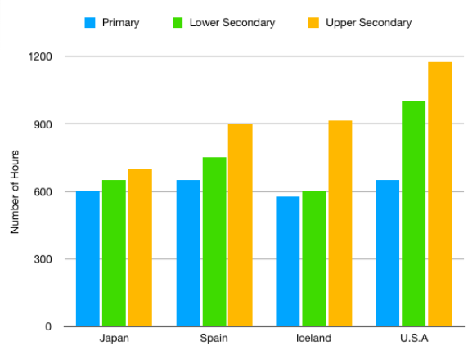

OUTLINE

OVERVIEW:

BODY:

The chart supplies data regarding teaching hour numbers each year of teachers in four various countries in 2001.
Overall, the number of teaching hours in the USA took the lion's share in all kinds of education, whilst Japan and Iceland quantities hit a trough in primary and secondary school. Additionally, high school figure surpassed those of the others throughout 2001.
As the chart reveals, the American teaching hour quantity of secondary and high school , hitting a peak of nearly 1000 and 1200 respectively and this number of American primary schoJap consitiuted approximately 650, as high as that of Spain. By contrast, Japanese and Iceland ‘s numbers of primary and secondary school ranked at the bottom of the list , with 550 for the former and 600 for the latter.Meanwhile , Japanese figure in high school amounted to nearly 700 , standing at the last position on the list .
As for Spanish figure, the teaching number of primary school accounted for 900 hours, resembling to / equal to / identical to that of Iceland. In addition, the figure of secondary school comprised averagely 700 hours , standing behind that of USA.
215 words 50p
+lengthy writing!
+many repetitions!
BAND SCORE: 4.5

